NATIONAL CHEMISTRY OLYMPIAD 2026

ASSIGNMENTS PRELIMINARY ROUND 1

To be held between 12th and 30th January 2026


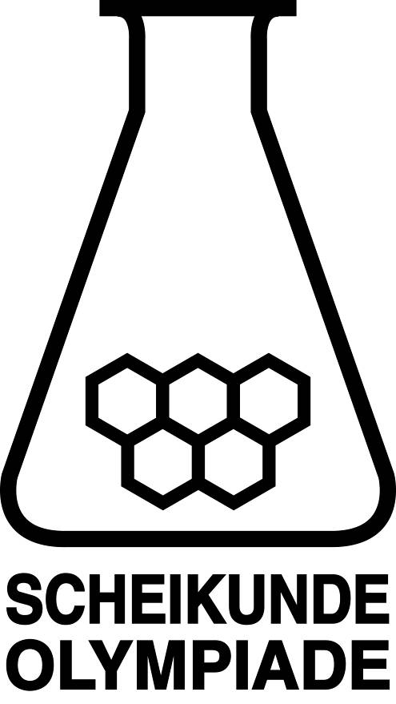


▪ This preliminary round consists of 25 multiple choice questions divided over 9 topics, and 2 problems with a total of 8 open questions, in addition to an answer sheet for the multiple choice questions.
▪ Use the answer sheet to answer the multiple choice questions.
▪ For the open questions, use a separate answer sheet for each of the two problems. Remember to include your name on each sheet.
▪ The maximum score for this paper is 73 points.
▪ The preliminary round lasts two hours in total.
▪ Required materials: (graphic) calculator and BINAS 7th edition, ScienceData 1st edition or BINAS 5th edition, English version. “Green chemistry” table is included.
▪ The total number of points available for each question is stated.
▪ Unless otherwise stated, standard conditions apply: T = 298 K and p = p₀.

This test was made possible with the support of the following people:
Olav Altenburg
Kees Beers
Imre Bekkering
Alex Blokhuis
Johan Broens
Guus Bukkems
Jacob van Hengst
Dick Hennink
Marijn Jonker
Emiel de Kleijn
Jasper Landman
Bob Lefeber
Evert Limburg
Marte van der Linden
Han Mertens
Anna Reinhold
Joran de Ridder
Geert Schulpen
Nena Slaats
Eveline Wijbenga
Emmy Zeetsen
Kjeld Zwitserloot

The final editing was done by:
Martin Groeneveld, Piet Mellema and Pia Scheffer

The test was translated into English by:
Lilian Buuron
Eline Knol
Riëtte Pienaar
Jan Rombach
Lauren Rutherford
Alex Schaeffers

- Multiple choice questions (total 50 points)
For each question, write your answer (letter) on the answer sheet. The answer sheet can be found at the end of this examination booklet.
Marks: 2 points for each correct answer.
 |  | Carbon chemistry
1 |  | How many monobromosubstitution products are formed when methylbutane reacts with bromine under the influence of UV light?  Take stereoisomerism into account.
 | A | 3
 | B | 4
 | C | 5
 | D | 6
2 |  | How many noncyclic isomers exist with the molecular formula C₃H₆S?  Take stereoisomerism into account.
 | A | 4
 | B | 5
 | C | 6
 | D | 7
 | E | 8
3 |  | Below is a fragment from the middle of a polymer molecule.  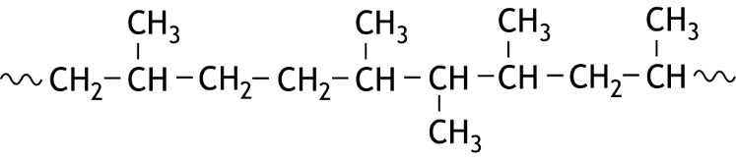  From which monomer / monomers could this polymer be formed?
 | A | only propene
 | B | ethene and but-2-ene
 | C | ethene and propene
 | D | propene and but-2-ene
4 |  | Amylose is a carbohydrate formed by the polymerization of glucose molecules.  What is the average degree of polymerization of amylose when the average molar mass is 3.29∙10⁵ g mol^{—1}?
 | A | 5.07∙10²
 | B | 1.83∙10³
 | C | 1.85∙10³
 | D | 2.03∙10³

 |  | Thermochemistry
5 |  | The energy diagram for the reaction A + B → C is shown below:  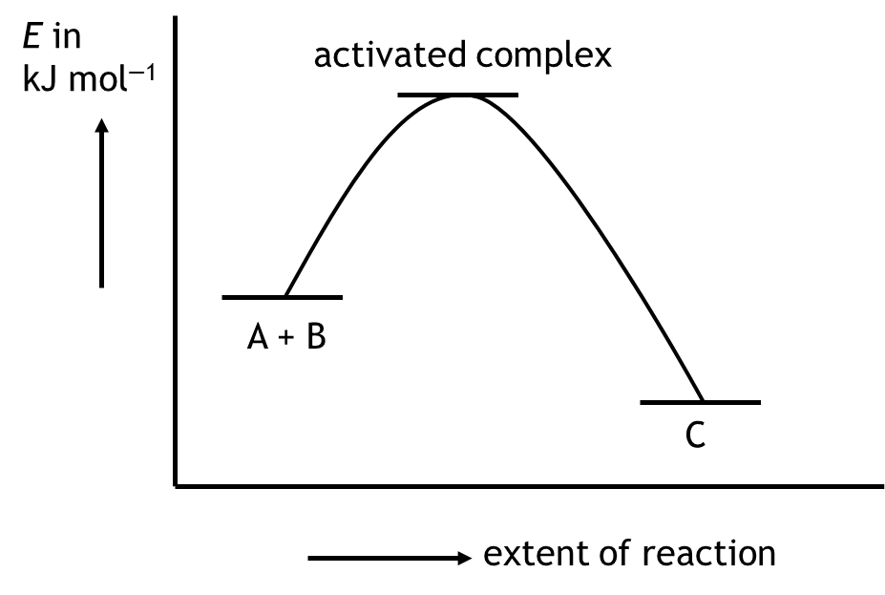  Which of the following statements is true?  I The reaction is endothermic.  II Addition of a catalyst increases the energy level of reactants A and B.
 | A | none
 | B | only I
 | C | only II
 | D | both
 |  | Reaction rate and equilibrium
6 |  | The following equilibria are given:  I 2 NO₂(g) N₂O₄(g)  II 3 O₂(g) 2 O₃(g)  Which equilibrium shifts to the right with increasing temperature?
 | A | none
 | B | only I
 | C | only II
 | D | both
7 |  | In the reaction  2 N₂H₄(l) + N₂O₄(l) → 3 N₂(g) + 4 H₂O(g)  the rate at which N₂H₄ reacts is 3.5∙10^{‒4} mol s^{‒1}.  What is the rate in mol s^{‒1} at which nitrogen is formed?
 | A | 2.3∙10^{‒4}
 | B | 3.5∙10^{‒4}
 | C | 5.3∙10^{‒4}
 | D | 1.1∙10^{‒3}

8 |  | In a closed vessel the following equilibrium is established:  CaCO₃(s) CaO(s) + CO₂(g)  At some point the equilibrium is disturbed because the volume of the vessel is increased while the temperature remains constant.  Which reaction is temporarily favoured immediately after this disturbance?  After some time, a new equilibrium is established.  After the equilibrium is re-established, will the CO₂ concentration have decreased, remained the same, or increased compared to the concentration before the disturbance?
 |  | temporarily favoured | concentration of CO₂
 | A | reaction to the left | decreased
 | B | reaction to the left | remained the same
 | C | reaction to the left | increased
 | D | reaction to the right | decreased
 | E | reaction to the right | remained the same
 | F | reaction to the right | increased
 |  | Structures and formulae
9 |  | A double salt contains sodium ions, magnesium ions and sulfate ions. The formula for a double salt is Na_{x}Mg_{y}(SO₄)_{z}.  What are the values for x , y, and z in the double salt if the molar ratio of the sodium ions and magnesium ions is 1 : 1?  x y z
 | A | 1 1 2
 | B | 1 2 3
 | C | 2 1 2
 | D | 2 2 3
 | E | 3 3 3
10 |  | How many lone pairs should be drawn in the Lewis structure of nitromethane, CH₃NO₂? Assume that the C, N, and O atoms obey the octet rule.
 | A | 3
 | B | 4
 | C | 5
 | D | 6
 | E | 7

11 |  | The acidity of an acid depends, among other things, on the number of resonance structures of its conjugate base.  The structural formulas of two acids are shown below.  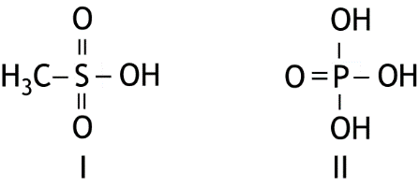  How many resonance structures can be drawn for the conjugate base of each of the above acids in which both the S and P atoms have no formal charge?
 |  | number of resonance structures of the conjugate base of I |  | number of resonance structures of the conjugate base of II
 | A | 2 |  | 2
 | B | 2 |  | 3
 | C | 2 |  | 4
 | D | 3 |  | 2
 | E | 3 |  | 3
 | F | 3 |  | 4
 | G | 4 |  | 2
 | H | 4 |  | 3
 | I | 4 |  | 4
12 |  | Ethinylestradiol is a substance used in contraceptives. Its structural formula is shown below.  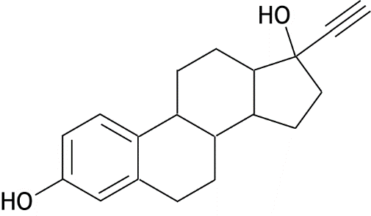  How many carbon atoms have a coordination number of 2 and how many carbon atoms have a coordination number of 3 in a molecule of ethinylestradiol?
 |  | number of C atoms with a coordination number of 2 | number of C atoms with a coordination number of 3
 | A | 2 | 5
 | B | 2 | 6
 | C | 2 | 11
 | D | 2 | 12
 | E | 8 | 5
 | F | 8 | 6
 | G | 8 | 11

 |  | pH and acid–base
13 |  | How many grams of HClO (M = 52.46 g mol⁻¹) and how many grams of NaClO  (M = 74.44 g mol⁻¹) can be dissolved in 1.00 L of water to prepare a buffer solution with a pH of 7.83?  HClO NaClO
 | A | 1.0 g 3.8 g
 | B | 1.0 g 1.9 g
 | C | 1.9 g 1.0 g
 | D | 3.8 g 1.0 g
14 |  | Four different solutions with a volume of 1.0 L, each containing a different acid, all have a pH of 2.5.  In which solution is the smallest number of moles of acid dissolved?
 | A | CH₃COOH
 | B | HF
 | C | HIO₃
 | D | HNO₂
15 |  | In a 0.1200 M solution of a monoprotic weak acid, 2.3% of the acid is ionised.  What is the value of Kₐ for this acid?
 | A | 2.4·10^{—2}
 | B | 5.4·10^{—2}
 | C | 5.4·10^{—4}
 | D | 6.3·10^{—5}
 | E | 6.5·10^{—5}
 |  | Redox and Electrochemistry
16 |  | Copper reacts with a solution of nitric acid according to the following unbalanced chemical reaction equation:  Cu + H⁺ + NO₃— → Cu²⁺ + NO + H₂O  What is the coefficient of H⁺ in the balanced reaction equation?
 | A | 2
 | B | 4
 | C | 6
 | D | 8

17 |  | How long should a 3.5 A current be applied to a solution containing Zn²⁺ ions to obtain 5.0 g of zinc?  Given: 1 A = 1 C s⁻¹ and the charge of one mole of electrons is 96 485 C.
 | A | 1.1·10³ s
 | B | 2.1·10³ s
 | C | 4.2·10³ s
 | D | 1.5·10⁴ s
 |  | Analysis
18 |  | A barium nitrate solution is added to:  I a sodium sulfite solution  II a potassium ethanoate solution  Which addition produces a cloudy mixture?
 | A | neither addition
 | B | only the addition to the sodium sulfite solution
 | C | only the addition to the potassium ethanoate solution
 | D | both additions
19 |  | Natural bromine consists of the isotopes Br—79 and Br—81.  These isotopes occur in a percentage ratio of 50.7 : 49.3.  How many peaks appear in the mass spectrum of natural bromine?
 | A | 2
 | B | 3
 | C | 4
 | D | 5
 | E | 6
20 |  | The mass percentage of theobromine (C₇H₈N₄O₂; M = 180.2 g mol⁻¹) in cocoa beans is determined as follows. A 2.95 g sample of cocoa beans is treated with 25.00 mL of a 0.0100 M AgNO₃ solution. All of the theobromine is converted into solid AgC₇H₇N₄O₂. After filtration, the filtrate is titrated with a 0.0108 M KSCN solution. The reaction that occurs during the titration is:  Ag⁺(aq) + SCN—(aq) → AgSCN(s)  The endpoint of the titration is reached after 7.69 mL has been added.  What is the mass percentage of theobromine in the cocoa beans?
 | A | 0.507%
 | B | 1.02%
 | C | 1.53%
 | D | 9.81%

 |  | Calculations
21 |  | Complete combustion of an amount of a hydrocarbon produces 8.0 dm³ of CO₂(g) and 12.0 dm³ of H₂O(g).  What could be the molecular formula of this hydrocarbon?
 | A | C₂H₆
 | B | C₃H₄
 | C | C₃H₆
 | D | C₄H₆
 | E | C₈H₁₂
22 |  | The only source of copper in a copper ore is the mineral malachite, Cu₂CO₃(OH)₂ (M = 221.1 g mol⁻¹).  From a 1.00 kg sample of this ore, 47.0 g of metallic copper is obtained.  What mass percentage of the ore consists of malachite, assuming all the copper present in the sample is recovered?
 | A | 8.18%
 | B | 16.4%
 | C | 28.7%
 | D | 32.7%
 | E | 57.5%
23 |  | How many millilitres of a 0.327 M CuSO₄ solution must be diluted with water to a total volume of 1.00 L to obtain a 0.100 M CuSO₄ solution?
 | A | 3.27 mL
 | B | 30.6 mL
 | C | 32.7 mL
 | D | 306 mL
24 |  | How many nitrogen atoms are present in 486 g of N₂O₅?
 | A | 1.35·10²⁴
 | B | 2.71·10²⁴
 | C | 5.42·10²⁴
 | D | 1.90·10²⁵
 |  | Green chemistry
25 |  | Which combination of atom economy and yield results in the lowest E-factor?
 |  | atom economy | yield
 | A | low | low
 | B | low | high
 | C | high | low
 | D | high | high

Open questions (total 23 points)
- Pilsner (9 points)
Pilsner is a type of beer that is widely consumed in the Netherlands. Pilsner has a pH between 4.1 and 4.9 and is therefore moderately acidic. This low pH is caused by the presence of several acids.
A particular pilsner was analysed for the presence of a number of common organic acids found in beer. The molar concentrations of these organic acids in the analysed pilsner are listed in Table 1, which also gives the number of acidic groups (COOH groups) per molecule.
Table 1
Acid name | Molar concentration in the pilsner  (mmol L^{—1}) | Number of  COOH groups per molecule
malic acid | 0.433 | 2
pyruvic acid | 0.545 | 1
lactic acid | 1.099 | 1
acetic acid | 0.466 | 1
citric acid | 0.562 | 3
succinic acid | 0.415 | 2
fumaric acid | 0.362 | 2
total | 3.882
In addition to the organic acids listed in Table 1, a number of unknown organic acids are also present in the pilsner. In this problem it is assumed that all acidic groups in these unknown organic acids are also COOH groups. To determine the amount of COOH groups present in these unknown organic acids in the analysed pilsner, a titration with a sodium hydroxide solution can be performed. During the titration, the pH of the solution is monitored, and the titration is stopped once the pH reaches 8.2. At this pH, it may be assumed that all COOH groups of all organic acids present have reacted.
Before the titration can begin, the CO₂ present in the pilsner must be removed, because otherwise the result of the titration will not give an accurate picture of the total amount of organic acids in the pilsner.
- Explain whether the presence of CO₂ in the pilsner during the titration would result in a
value for the total amount of organic acids that is too high or too low. 2
The CO₂ is removed from the pilsner. Assume that neither the volume nor the rest of its composition changes in the process. The CO₂-free pilsner is then titrated with a sodium hydroxide solution, where the OH⁻ ions react with all COOH groups.

When the analysed pilsner contains only the organic acids listed in Table 1, it can be calculated that an average of 1.601 mol of COOH groups are present per mole of organic acid.
- Show this calculation. 2
The analysed pilsner contains, in addition to the COOH groups from the acids listed in Table 1, COOH groups from other organic acids as well. These COOH groups are referred to below as the extra COOH groups.
To determine the total number of COOH groups in the analysed pilsner, the contents of one bottle of pilsner were made CO₂-free. From the CO₂-free pilsner, 25.00 mL was pipetted into an Erlenmeyer flask. The titration was carried out with a 0.0560 M sodium hydroxide solution. A volume of 3.14 mL was required to bring the pH of the solution in the Erlenmeyer to 8.2.
- Calculate the number of mmol of extra COOH groups per bottle of the analysed pilsner.
One bottle contains 330 mL of pilsner. 5

- Disaster in Beirut (14 points)
On the 4th of August 2020 a large explosion occurred in the harbour of Beirut, the capital of Lebanon.
The cause of the explosion was linked to a large illegal storage of ammonium nitrate (NH₄NO₃) in a warehouse in the port of Beirut. A fire broke out in a neighbouring warehouse, which then spread to the one containing 2750 tons of ammonium nitrate, after which the explosion occurred.
Ammonium nitrate is produced through an acid-base reaction of ammonia with a nitric acid solution. After the reaction, a separation technique is applied.
- Carry out the following assignments:
— give the equation of the acid-base reaction that occurs when ammonia is added to a
nitric acid solution;
— give the name of the separation technique that can be used to obtain solid
ammonium nitrate from the resulting mixture. 2
- Give the name of the two types of bonds that are present in solid ammonium nitrate. 2
At high temperatures, a decomposition reaction occurs:
2 NH₄NO₃(s) → 2 N₂(g) + O₂(g) + 4 H₂O(g) (reaction 1)
Large amounts of gas are formed during this decomposition reaction.
- Calculate how many m³ of gas are formed if 2750 tons of ammonium nitrate decompose according to the above reaction equation at a temperature of 1000 K.
Give your answer to the correct number of significant figures.
Use the following data:
— 1 ton = 1000 kg;
— the volume of 1 mol of gas at 1000 K is 82.1 dm³. 4
The decomposition reaction of ammonium nitrate is exothermic. The energy that is released during the explosion causes the products of the reaction to heat up and contributes to the expansion of volume.
- Calculate, using the enthalpies of formation from your data booklet, the reaction enthalpy
of reaction 1 in J per mole of ammonium nitrate. 3
An explosion of ammonium nitrate can also occur if it is mixed with petrol (C₇H₁₆).
- Give the reaction equation for the reaction that occurs during this explosion. In this
reaction, nitrogen, water vapour and carbon dioxide are formed. 3

Green Chemistry
The twelve principles of green chemistry are:
1. Prevention Preventing waste is better than treating or cleaning up waste after it is created.
2. Atom economy Synthetic methods should try to maximize the incorporation of all materials used in the process into the final product. This means that less waste will be generated as a result.
3. Less hazardous chemical syntheses Synthetic methods should avoid using or generating substances toxic to humans and/or the environment.
4. Designing safer chemicals Chemical products should be designed to achieve their desired function while being as non-toxic as possible.
5. Safer solvents and auxiliaries Auxiliary substances should be avoided wherever possible, and as non-hazardous as possible when they must be used.
6. Design for energy efficiency Energy requirements should be minimized, and processes should be conducted at ambient temperature and pressure whenever possible.
7. Use of renewable feedstocks Whenever it is practical to do so, renewable feedstocks or raw materials are preferable to non-renewable ones.
8. Reduce derivatives Unnecessary generation of derivatives—such as the use of protecting groups—should be minimized or avoided if possible; such steps require additional reagents and may generate additional waste.
9. Catalysis Catalytic reagents that can be used in small quantities to repeat a reaction are superior to stoichiometric reagents (ones that are consumed in a reaction).
10. Design for degradation Chemical products should be designed so that they do not pollute the environment; when their function is complete, they should break down into non-harmful products.
11. Real-time analysis for pollution prevention Analytical methodologies need to be further developed to permit real-time, in-process monitoring and control before hazardous substances form.
12. Inherently safer chemistry for accident prevention Whenever possible, the substances in a process, and the forms of those substances, should be chosen to minimize risks such as explosions, fires, and accidental releases.
atom economy
percentage yield
E-factor

47th National Chemistry Olympiad 2026 preliminary round 1
Answer sheet: Multiple Choice Questions

Name:

Teacher:

School:

no. | Answer  letter | (score)
1
2
3
4
5
6
7
8
9
10
11
12
13
14
15
16
17
18
19
20
21
22
23
24
25
 | Total

